Measure a mobile phone using slide calipers

**Aim:**

* . To understand and get familiar with the use of the vernier calipers.
* To measure the diameter of a mobile phone.
* To measure the external diameter and find the volume.

**Apparatus:**

* Slide caliper.
* Mobile phone.
* Paper.
* Pencil.
* Eraser.
* Calculator

**Theory:**

If you look at the slide calipers you will see there are a main scale and a vernier scale. There have two zaw,which is external and internal zaws.And this zaws are moveable. They actually slide from one side to another side. That's why it's called slide calipers.So using this became move it from the right side to the left side. When we measure something we put it between this two zaws When we will measure the length the principally is we need to find first length.

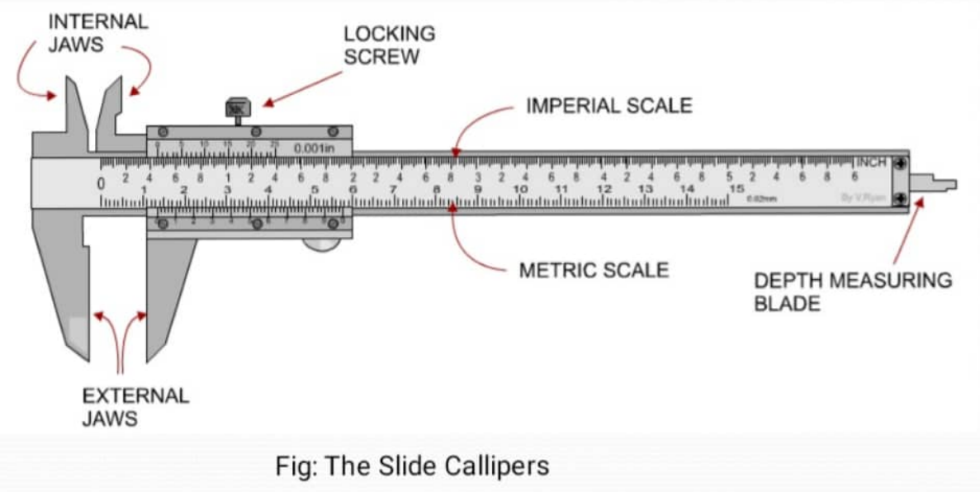

Length=main scale reading +vernier coincidence * vernier constant - (+-e). Vernier scale has 20 spaces. It means that here this is the 20th space of the vernier scale which is equal valid to the 19 space of the main scale. They read a slide difference in between the space of main scale and vernier and this difference known as vernier constant. The main scale read by mm.0-10 mm is completely 1cm. When vernier scale has 20 space and main scale has 19 space then VS 20=MS 19

VS 20=19mm, Vs=1=19/20mm

=0.95m

VC-MS(1sp)-VS(1sp)

=1mm-0.095mm, =0.05mm.

**Procedure:**

In order to measure the diameter, external diameter, depth and volume. I had to first determine the (i)Least count and (ii) Zero error before taking any measurement. Least count. To get the correct diameter the zero error was determined by checking if the zero on the main scale and the Vernier scale coincide, in this case there is no zero error. The internal diameter of the beaker was measured by gently placing the inner jaws inside the beaker while the jaws firmly touch the ends of the beaker without deforming it. This was repeated at least five times for accuracy. Lastly the volume of the mobile-phone was calculated using the inner part of the jaws to determine the external diameter of the beaker and using the prong to determine its depth. The volume of the beaker is given by the relationV= π

г2h= π (d2)2h=14π d2h r = internal radius.

**Discussion:**

Before measurements were obtained on the vernier caliper made sure it was cleaned. Not forgetting to check for any zero error of which the instrument used had no error. This experiment was a success and the volume was determined. When closing jaws and knobs did not over tighten as this may affect the material being measured or even break the beaker and cause injury. Each measurement of each material had to be repeated for five different times on the vernier caliper to get concordant results

**Conclusion:**

In this experiment we have attested that Venier calipers can are one of the most employed measuring instruments that have played an important role in measuring because the data collected shows much great accuracy compared to a measuring tape. This accuracy means that even the volume of anything can be easily